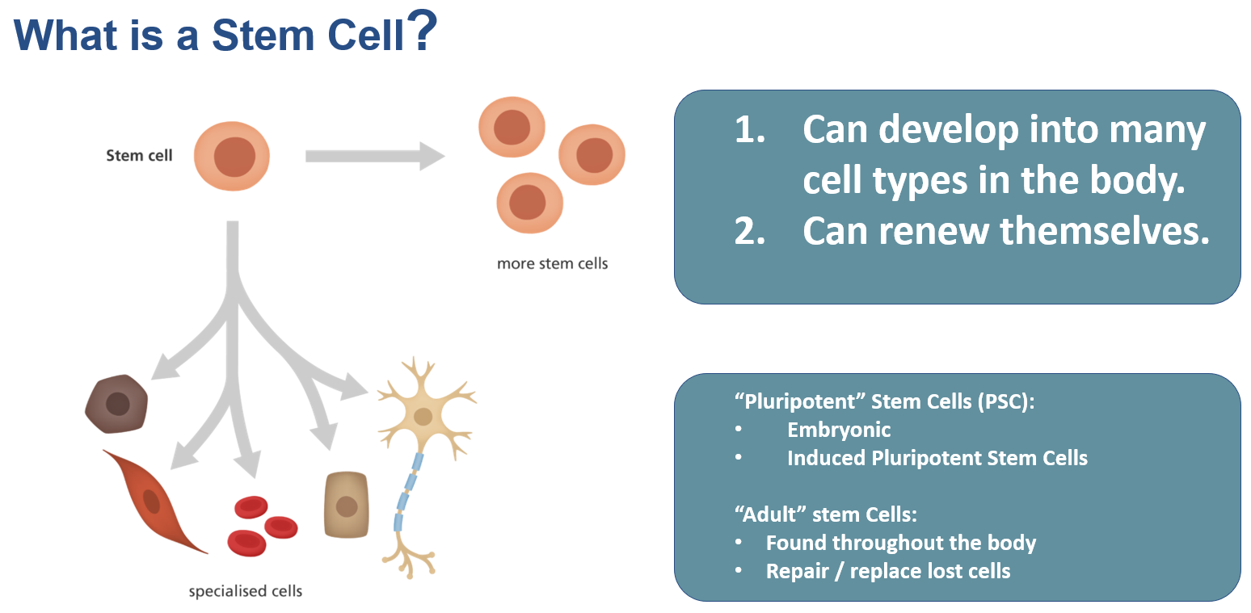

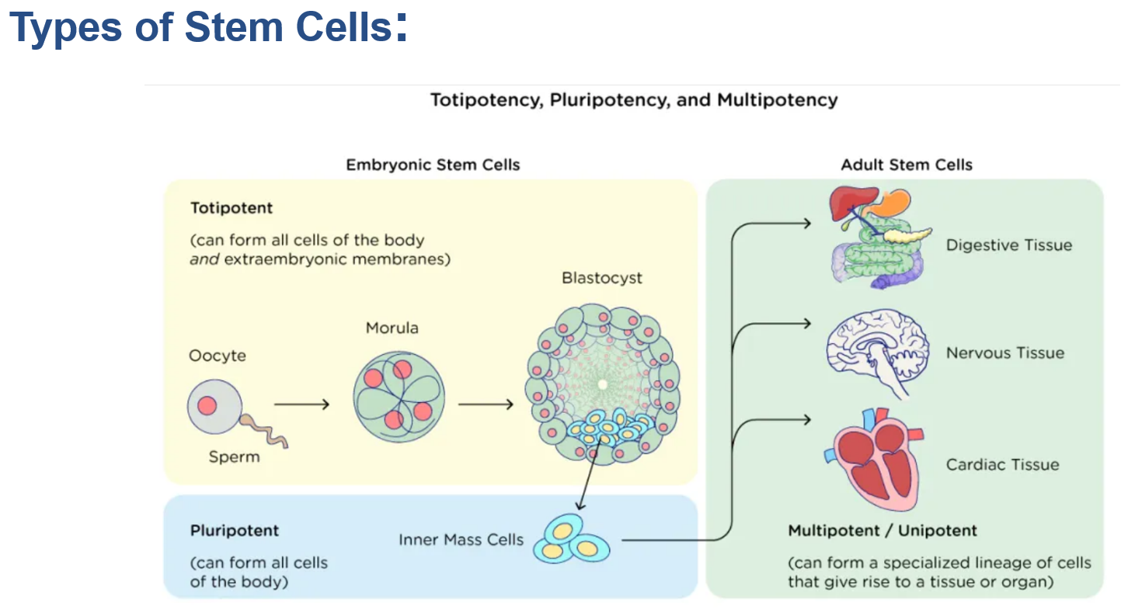

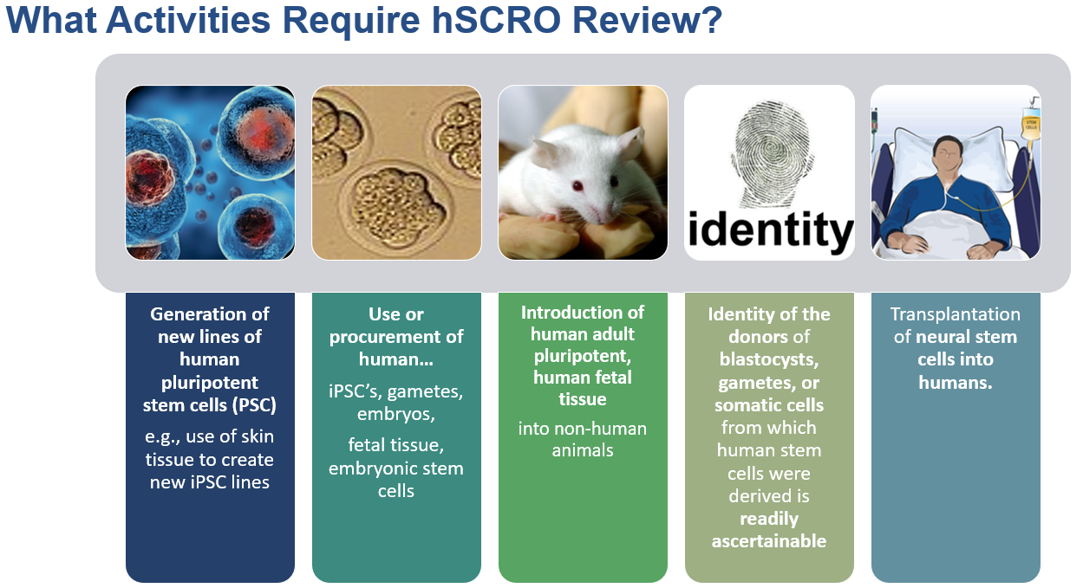

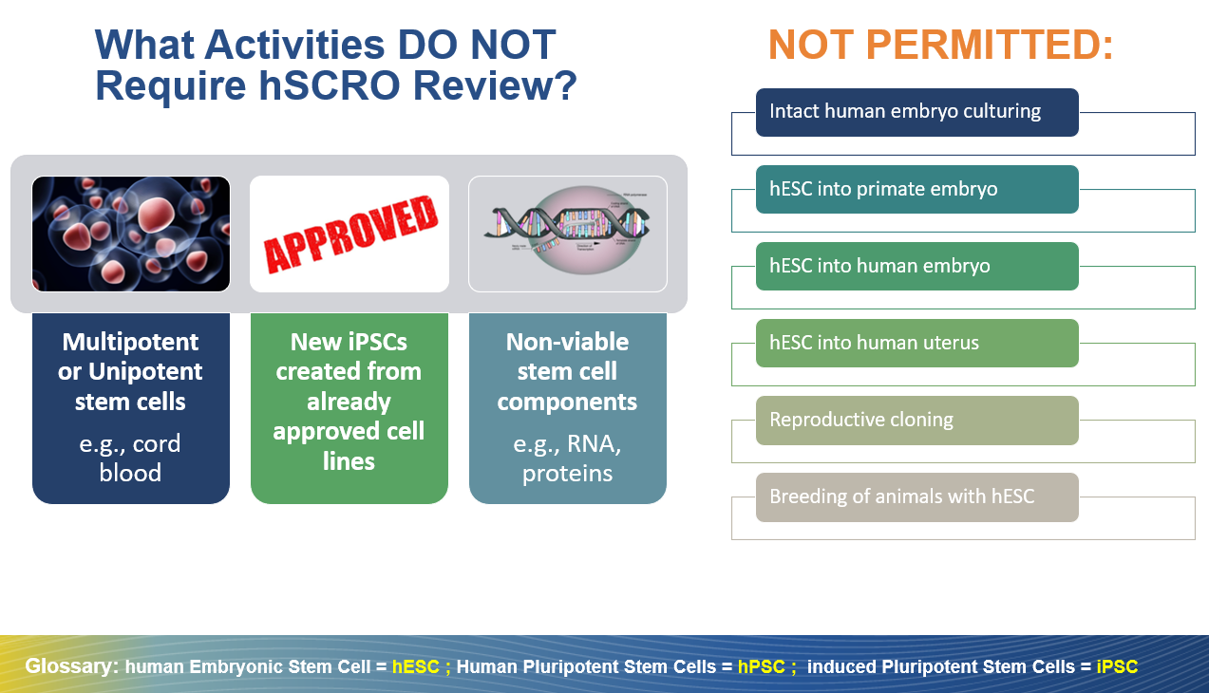

For activities that require hSCRO review, submit a NEW Protocol via the hSCRO submission and management system called Zot hSCRO

How to Submit NEW Protocols for hSCRO review webpage summarizes considerations when submitting your protocol for hSCRO review

All new hSCRO Protocols require Full Committee review.
  - See the hSCRO Meetings and Deadlines page for guidance.
  - hSCRO Full Committee meetings usually occur on the first Thursday of the month.
- Other Ancillary (IRB, IACUC, IBC) approvals may also be applicable.
- See the Cell Line Provenance Policy for details of submission requirements for research materials (e.g., submission requirements for adding registered pluripotent stem cell lines vs. fresh somatic cells to the protocol)

Additional guidance for approved hSCRO protocols:
- Amendments to HSCRO Approved Research
- Your hSCRO protocol is about to expire, Submitting a Renewal for hSCRO review
- Submitting Closing Reports upon research completion

Resources:
- UCI hSCRO Main Webpage & Zoom Office Hours link
- Email: hSCRO@uci.edu
- Phone: (949) 824-8170 — please leave a voicemail.
- Subscribe to the hSCRO Listserv: Send a blank email to: or-hscro+subscribe@uci.edu

