

NATIONAL CANCER INSTITUTE
CENTRAL IRB INITIATIVE

Handbook for Local Institutions

Handbook for Local Institutions

Additional copies are available from the CIRB website (https://ncicirb.org).

If you have any questions, contact the CIRB Operations Office:

CIRB Operations Office
c/o The EMMES Corporation
401 N. Washington St., Suite 700
Rockville, MD 20850
(Tel) 1-888-657-3711
(Email) ncicirbcontact@emmes.com

The CIRB Initiative is based in the Cancer Therapy Evaluation Program, Division of Cancer Treatment and Diagnosis, National Cancer Institute, National Institutes of Health, Department of Health and Human Services.

Contents
1.0 Introduction 1
2.0 CIRB Initiative 1

CIRB: General Information 1
CIRB Members 2
CIRB Meeting Schedule 2
Requirements for Using the CIRB 2
Participation Fee 2
AAHRPP Accreditation 3
3.0 CIRB Model 3
Responsibilities of the CIRB 3
Responsibilities of Signatory Institution 5
4.0 How to Enroll in the CIRB Initiative 8
Enrollment Support 8
Eligibility Requirements 8
CIRB Enrollment Process 9
5.0 Using the CIRB 10
Identifying Local Context Considerations 10
Opening a Study using the CIRB 12
Continuing Review 12
Amendment Review 12
Annual Worksheet Review 12
Re-consent Requirements 13
Closing a Study at an Institution 13
Transferring a Study Participant to Another Institution 14
6.0 Special Considerations for Institutions Relying on the Pediatric CIRB 14
Assent Requirement 14
Documentation of Assent 14
Waiver of Assent Requirements 15
Consent at Age of Majority 15
7.0 Reporting Unanticipated Problems and/or Serious or Continuing Noncompliance to the CIRB 15
Potential Unanticipated Problems 15
Potential Serious or Continuing Noncompliance 16
Protocol Deviations or Adverse Events 16
Completion of the Reporting Form 16
Reporting to OHRP and FDA 17
8.0 Submission of Locally-Developed Materials 17
9.0 Updating Information with the CIRB 17
Adding, Changing, or Deleting Institutions, Principal Investigators, or Research Staff 17
Revision of Previously Approved Worksheets 17
10.0 Communications 18
List of CIRB Document Postings 18
CTSU Website 18
CIRB Helpdesk 18
Study-Specific Notifications 18
Presentations about CIRB Initiative 19
CIRB Local Site Advisory Panel (LSAP) 19
CIRB Assistance with Response to Network Group Audits for Studies Under the CIRB 19
11.0 Obtaining a CTEP Site Code 19
12.0 Obtaining a CTEP Person ID 19
Appendix 1: How to Access, Copy, and Edit Worksheets in IRBManager 20
Appendix 2: List of Referenced URLs 23
Appendix 3: CIRB Operations Office Contact Information 24
Appendix 4: Key Terms 25

1.0 Introduction

This Handbook introduces local institutions to the purpose and function of the National Cancer Institute’s (NCI) Central Institutional Review Board (CIRB) Initiative and provides information to guide the process of enrollment and utilization.

The work of the NCI CIRB Initiative is performed by the CIRB Operations Office. CIRB Operations Office staff provides support to local institutions via the CIRB website (https://ncicirb.org) and the CIRB Helpdesk.

2.0 CIRB Initiative

Background

In 1996, the National Cancer Institute (NCI) Clinical Trials Program Review Group was tasked with addressing the challenge of responding to expanding opportunities of new therapeutics and technology while reducing costs of research through efficiencies. The Review Group met six times over an 11-month period and its recommendations, known as “The Armitage Report,” included establishing a “streamlined IRB process” for multi-center trials such as those coordinated by the NCI’s Clinical Trials Cooperative Group Program.
Due to the importance of investigators from multiple sites using a single version of a protocol, local IRBs reviewing Cooperative Group trials could not make any changes in the protocol and were restricted to approving the protocol supplied by the Cooperative Group or not approving the study for participation at their institution. This situation resulted in redundant reviews across the nation as local IRBs reviewed the same protocol without the ability to effect changes.
In response to the Armitage Report’s recommendation to streamline the IRB process, the NCI started the Central Institutional Review Board (CIRB) Initiative in 2001. The CIRB Initiative provides a more effective and efficient clinical research effort by conducting full board review centrally thus eliminating redundant processes.

In 2011 and 2012, the CIRB conducted a pilot study of the independent model. In this model, the CIRB acts as the IRB of record and is responsible for the local context review previously conducted by the institution as part of their facilitated review. After a successful pilot study, the CIRB adopted the independent model in 2013 for all enrolled institutions and any institution that joined the CIRB going forward. As of December 31, 2013, all institutions were transitioned to the independent model and all institutions operate under this model.

CIRB: General Information

The CIRB Initiative includes four CIRBs:

- Adult CIRB - Late Phase Emphasis (LPE) – established in 2001 for the review of phase 3 adult studies
- Adult CIRB - Early Phase Emphasis (EPE) – established in 2013 for the review of early phase studies
- Pediatric CIRB – established in 2004 for the review of Children’s Oncology Group studies
- Cancer Prevention and Control (CPC) CIRB – established in 2015 for the review of cancer prevention and control studies

In this Handbook, the term “CIRB” refers to all four CIRBs unless otherwise stated.

CIRB Members

The members of all CIRBs are a diverse group of distinguished healthcare professionals and patient advocates with expertise in oncology treatment, prevention, and control. No CIRB member is employed by the NCI. A listing of current members for each CIRB and their biosketch is available on the CIRB website (https://www.ncicirb.org) by clicking the “CIRB Members” link.

CIRB Meeting Schedule

The CIRBs meet on the following schedule:

- Adult CIRB – LPE – meets on the first and third Thursday of each month
- Adult CIRB – EPE – meets on the first and third Tuesday of each month
- Pediatric CIRB – meets on the second Thursday of each month
- CPC CIRB – meets on the fourth Thursday of each month

A list of CIRB meetings can be found on the CIRB website (https:/ncicirb.org) by clicking the “Meeting Information” link.

Requirements for Using the CIRB

Enrolling institutions must meet the following criteria:

- Each institution conducting Network Group, ETCTN, NCORP, or DCP Consortia research (enrolling, consenting, and administering study intervention) must have a valid CTEP Site Code (See Section 11.0 for more information).
- All identified institutional staff with the exception of the Signatory Official (SO) (individual signing the Authorization Agreement and Division of Responsibilities document) must have CTEP Person ID (See Section 12.0 for more information) and active CTEP-IAM accounts.

Participation Fee

There is no charge for an institution to join and participate in the CIRB Initiative.

AAHRPP Accreditation

The CIRB is fully accredited by the Association for the Accreditation of Human Research Protection Programs (AAHRPP). The CIRB received full accreditation in December 2012.

3.0 CIRB Model

The CIRB is the IRB of record and is responsible for both study review and review of local context considerations for enrolled Signatory Institutions. (See Section 5.0 for more information on local context considerations)

Responsibilities of the CIRB

An Authorization Agreement and Division of Responsibilities document is signed by the Signatory Institution in the enrollment process. This document outlines the responsibilities performed by the CIRB and those performed by the local institution. The CIRB is responsible for the following:

CIRB Membership

The CIRB maintains membership that satisfies the requirements of 45 CFR 46 and 21 CFR 56 and provide special expertise as needed to adequately assess all aspects of each study. The CIRB Operations Office actively monitors CIRB member composition and tenure and identifies possible future members to ensure the requirements are maintained.

Study-Specific Reviews

The CIRB conducts the study-specific reviews as required by the regulations: initial review, amendment review, and continuing review. In addition, any other study-specific documents submitted by the Study Chair are reviewed per the CIRB Standard Operating Procedures (SOPs) and federal regulations.

Review of Local Context Considerations

“Local Context” is considered the unique considerations for an institution and the Principal Investigator (PI) when conducting NCI-sponsored research. For example, the institution local context includes boilerplate language for inclusion in the consent form and compliance with applicable state and local laws. The PI local context includes the resources available to support research and the safeguards used to protect vulnerable populations. The Signatory Institution reports its local context considerations to the CIRB for review using three Worksheets that reflect the organization, the Principal Investigator, and the specific protocol. Hyperlinks to each worksheet are provided below:

    - Annual Signatory Institution Worksheet About Local Context
    - Annual Principal Investigator Worksheet About Local Context
    - Study-Specific Worksheet About Local Context

See Section 5.0 for more information on the Worksheets.

Review of Potential Unanticipated Problems and/or Serious or Continuing Noncompliance

The CIRB reviews potential unanticipated problems and/or serious or continuing noncompliance when the Signatory Institution or other institutional representative reports an incident, experience, or outcome to the CIRB.

Reporting to OHRP and FDA

The CIRB reports any unanticipated problem determination, serious noncompliance, continuing noncompliance determination, suspension, or termination to OHRP, the FDA, and the NCI Signatory Official. The CIRB reports for trial-wide and locally-occurring events.

Review of Individual Adverse Events

The CIRB reviews individual Adverse Event Reports for studies without Data and Safety Monitoring Board (DSMB) or equivalent monitoring body per the CIRB SOPs.

Documentation

The CIRB posts all study-specific documents related to CIRB reviews to a restricted access website. Reviews posted prior to September 29, 2014 are available on the CIRB website (https://ncicirb.org) Participant’s Area. Reviews since June 2013 and all new posting are available on the CTSU website (https://www.ctsu.org) under the study-specific CIRB Documents tab.

To access a summary of recent CIRB postings on the CTSU website in real time, the Signatory Institution Principal Investigators and research staff can view the CIRB Updates Tab on the right side of the CTSU password-protected homepage. The listing includes the date posted, the protocol ID, the event name, and a link to the associated documents. Screenshots below show how to assess the CIRB Updates tab.

CIRB Updates Tab
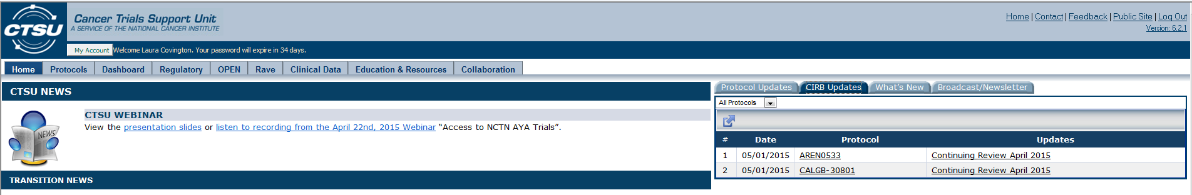

Close-Up View of CIRB Updates Tab
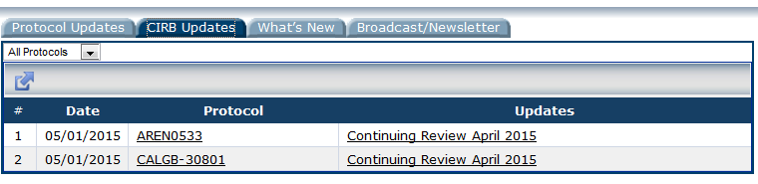

Within the CTSU website, reports of recent postings may be generated by clicking on the arrow about the # column in the table. Report options include export PDF, export Excel, export CSV, or print.

Historically, a summary of postings were distributed to institutions via the CIRB Website Posting Summary on the first and the fifteenth of each month. An archive of the historic Website Postings Summary created on or before May 1, 2015 can be found on the CIRB website (https://ncicirb.org) by clicking the “Website Postings Summary” tab.

Notification of New Materials

The CIRB notifies research staff and institutional designees of all CIRB actions, per written procedures, via institution-specific correspondence, broadcast email, and access to the restricted area of the CIRB website. See Section 10.0 about different CIRB communication methods.

Notification of Suspension of Authorization

The CIRB notifies the Signatory Institution immediately if there is ever a suspension or restriction of the CIRB’s authorization to review a study.

CIRB SOPs

The CIRB SOPs are available on the public side of the CIRB website.

Responsibilities of Signatory Institution

The Signatory Institution complies with the responsibilities as identified in the Authorization Agreement and Division of Responsibilities document. This agreement covers only NCI-sponsored studies reviewed by the CIRB and opened by the institution with the CIRB.

Compliance with the CIRB

The Signatory Institution Principal Investigator and research staff must comply with the CIRB’s requirements as defined in the CIRB SOPs and in correspondence from the CIRB.

Reporting of Components or Affiliate Institutions
The Signatory Institution representative reports to the CIRB the names of any Component or Affiliate Institutions that rely on the Signatory Institution’s oversight of the conduct of CIRB-approved research by identifying them on the Authorization Agreement and Division of Responsibilities document. The Signatory Institution representative must also provide the CTEP Site Code (See Section 11.0 for more information) for each institution listed.

Component Institutions meet all the following criteria:

- The FWA number for the Component Institution are the same as the Signatory Institution;
- The Component Institution operates under a different name than the Signatory Institution;
- The Signatory Institution has legal authority for the Component Institution;
- The boilerplate language and institutional requirements of the Component Institution are the same as the Signatory Institution; and
- The conduct of research at the Component Institution is monitored by the same office as the Signatory Institution.

Affiliate Institutions meet all of the following criteria:

- The local context considerations of the Affiliate Institution are the same as the Signatory Institution;
- The boilerplate language and institutional requirements of the Affiliate Institution are the same as the Signatory Institution; and
- The conduct of research at the Affiliate Institution is monitored by the same office as the Signatory Institution.

Research Performance

The Signatory Institution Principal Investigator ensures the safe and appropriate performance of the research at the Signatory Institution and at all Component and Affiliates. This includes, but is not limited to:

- Ensuring the initial and ongoing qualifications of investigators and research staff;
- Overseeing the conduct of the research;
- Monitoring protocol compliance
- Maintaining compliance with state, local, or institutional requirements related to the protection of human subjects;
- Providing a mechanism to receive and address concerns from local study participants and others about the conduct of the research; and
- Investigating, managing, and providing notification to the CIRB of any study-specific incidence, experience, or outcome that seems to rise to the level of an unanticipated problem and/or serious or continuing noncompliance. When notifying the CIRB of a potential unanticipated problem and/or serious or continuing noncompliance, the institution must provide a plan to manage the incident, experience, or outcome, including measures to prevent similar occurrences.

NOTE: As part of ensuring safe and appropriate performance of research the Signatory Institution has the authority to observe any aspect of the research process including observing the consent process. The CIRB retains the authority to direct this to be done when necessary.

Report to the CIRB

The Signatory Institution Principal Investigator notifies the CIRB by submitting a Potential Unanticipated Problem or Serious or Continuing Noncompliance Form via IRBManager when a regulatory deficiency has been cited on an audit that occurred during the time that the CIRB was responsible for the study review. The CIRB should be notified of any internal or external audit findings that would meet the following criteria per the Clinical Trials Monitoring Branch (CTMB) Audit Guidelines:

- Major IRB deficiency
- Major informed consent form deficiencies
- Unacceptable Accountability of Investigational Agents and Pharmacy Operations
- Major deficiencies related to the review of patient case records.

These deficiencies should be reported as potential serious noncompliance.

If a subsequent audit identifies the same type deficiency, it should be reported to the CIRB as potential continuing noncompliance. (See the Instruction Manual for Worksheet Completion in IRBManager for more information on the submission of the Form in IRBManager)

Submission of Required Documents

The Signatory Institution Primary Contact and Signatory Institution Principal Investigator complete and submit the Annual Signatory Institution Worksheet About Local Context and the Annual Principal Investigator Worksheet About Local Context in IRBManager to establish local context considerations.

The CIRB-approved Signatory Institution Principal Investigators complete and submit the Study-Specific Worksheet About Local Context in IRBManager to open a study.

Consent Form Requirements

- Incorporate CIRB-approved boilerplate language into the CIRB-approved model consent form;
- Make no language changes to the consent form with the exception of CIRB-approved boilerplate language;
- Obtain CIRB approval of changes to the boilerplate language prior to implementation; and
- Obtain CIRB approval of translations of the consent form prior to implementation.

NOTE: Including HIPAA Authorization language as part of boilerplate language is permitted. The CIRB does not approve the HIPAA Authorization language as it does not function as a Privacy Board however the CIRB will accept HIPAA Authorization language when submitted as part of the boilerplate.

Regulatory File

The Signatory Institution Principal Investigator maintains a regulatory file for each study under CIRB purview as per local institution and sponsor policy. The CIRB does not have any additional requirements for the maintenance of the regulatory file at the local institution. The CIRB maintains its own regulatory file of study reviews per CIRB SOPs.

Research involving Prisoners

The Signatory Institution conducts a local full board review of any study enrolling prisoners, since the CIRB is not constituted to review studies enrolling prisoners.

4.0 How to Enroll in the CIRB Initiative

Enrollment Support

The CIRB Operations Office has staff dedicated to helping you enroll in the CIRB Initiative. To request enrollment assistance, contact the CIRB Helpdesk by phone (1-888-657-3711) during the hours of 8:00 AM and 4:00 PM ET or via email at ncicirbcontact@emmes.com.

Institutions are encouraged to contact the CIRB Helpdesk at the beginning of the enrollment process. At the time of the initial contact, a representative from the CIRB Operations Office is assigned to assist you with the initial enrollment steps. If you have any questions about the CIRB, a conference call with individuals from your institutions may be arranged, if requested, to discuss the CIRB Initiative and independent model review in more detail.

Eligibility Requirements

To enroll in the CIRB, the following requirements must be met:

- Each institution conducting Network Group, ETCTN, NCORP, or DCP Consortia research (enrolling, consenting, and administering study intervention) must have a valid CTEP Site Code (See Section 11.0 for more information).
- All identified institutional staff with the exception of the Signatory Official (SO) (individual signing the Authorization Agreement and Division of Responsibilities document) must have CTEP Person ID (See Section 12.0 for more information) and active CTEP-IAM accounts.

CIRB Enrollment Process

To enroll in the CIRB, institutions must submit the forms and Worksheets as described below. The forms are available on the CIRB website. The Worksheets are completed in IRBManager (https://nci.my.irbmanager.com). IRBManager is an online system used to manage local context submissions. Access is given to all personnel who are identified on the Enrollment Form. Personnel obtain the rights to access IRBManager after Steps 1 and 2 are complete.

- Complete and email the NCI CIRB Signatory Institution Enrollment Form
  - If the institution does not have a local IRB, complete the “Oversight for Conduct of Research Questionnaire” provided by Helpdesk staff.
- Complete and mail two signed originals of the Authorization Agreement and Division of Responsibilities document
- Complete Annual Signatory Institution Worksheet About Local Context
- Complete Annual Principal Investigator Worksheet About Local Context
- Receive confirmation from the NCI CIRB of Completion of Enrollment

The Annual Signatory Institution Worksheet About Local Context and the Annual Principal Investigator Worksheet About Local Context need to be submitted simultaneously and are reviewed concurrently by the CIRB.

Completing the NCI CIRB Institution Enrollment Form

The NCI CIRB Signatory Institution Enrollment Form is located here: https://ncicirb.org/cirb/documents/NCI_CIRB_Enrollment_Form.doc.

Follow the instructions for each section of the form. Save the completed form in Microsoft Word and email it to the CIRB Helpdesk at ncicirbcontact@emmes.com.

Completing the Authorization Agreement and Division of Responsibilities

The Authorization Agreement and Division of Responsibilities document describes the arrangement with a Signatory Institution to rely on the CIRB for review of studies on the CIRB menu (See Section 3.0).

The Signatory Official should sign and date two original hard copies. Both original documents will be executed by the NCI. One will be returned to the enrolling institution for their records with the other retained by the CIRB Operations Office.

The Signatory Official must be a senior institutional official who has the authority to commit the entire institution named on the FWA, as well as all of the institutional components that have been listed in Section B to a legal binding agreement. This person must also have the authority to assure compliance of the institution and all its components to the Terms of the FWA. Generally, this is someone at the level of President, Chief Executive Officer (CEO), Vice President of a company, or at the level of President, Provost, Chancellor, Vice President or Dean of an academic institution, unless another official has been specifically delegated with this authority.

Completion and Approval of the Annual Worksheets

Annual Signatory Institution Worksheet About Local Context

This Worksheet should be completed by the Signatory Institution Primary Contact (for more information on the Signatory Institution Primary Contact see Appendix 5.0) using IRBManager. Detailed instructions on how to complete the Worksheet are located in section 2.0 of the Instruction Manual for Worksheet Completion in IRBManager.
Annual Principal Investigator Worksheet About Local Context

This Worksheet should be completed by the Signatory Institution Principal Investigator who will open CIRB-approved studies using IRBManager. Detailed instructions on how to complete the Worksheet are located in section 3.0 of the Instruction Manual for Worksheet Completion in IRBManager.
Confirmation of Completion of Enrollment

The CIRB Operations Office will verify that all enrollment steps have been completed and that the Annual Signatory Institution Worksheet and at least one Annual Principal Investigator Worksheet approval letter have been sent. At this point, a letter will be sent via email to the Signatory Institution Primary Contact, Signatory Institution Principal Investigators, and research staff confirming the requirements for enrollment are complete and that the Signatory Institution Principal Investigators can begin to open studies using the Study-Specific Worksheet About Local Context.

5.0 Using the CIRB

Identifying Local Context Considerations

Local context considerations are identified and reported to the CIRB by the Signatory Institution and Signatory Institution Principal Investigators via annual and study-specific Worksheets.

Local context considerations for the Signatory Institution include, but are not limited to:

- State and local laws,
- Conflict of interest policy,
- Boilerplate language for inclusion in the consent form,
- Any other institutional requirements, and
- Catchment area, where the institution’s study participant population for NCI-sponsored studies is located.

Local context considerations for Signatory Institution Principal Investigators include, but are not limited to:

- Resources available to support research,
- Extent of existing populations eligible for enrollment,
- Safeguards used to protect those populations,
- Privacy and confidentiality protections, and
- Any unique study-specific considerations.

Consent Form and Institutional Boilerplate Language

It is expected that most institutions will need to add boilerplate language to the CIRB-approved model consent forms. The CIRB expects that boilerplate language will be added to the CIRB-approved model consent form and that existing language will not be deleted or replaced. The submitted boilerplate language must indicate if it is to replace existing language.

No changes can be made to the CIRB-approved model consent form except CIRB-approved boilerplate language, removal of instruction/notes from the coordinating Group, and dates embedded to track changes. Any change made to the NCI-sponsored consent forms needs to be captured as institutional boilerplate and approved before it can be used. These changes include information captured in the consent form header and footer. If changes that are not CIRB-approved are made to the CIRB-approved model consent form, this will likely result in a finding at audit.

The boilerplate language is submitted to the CIRB via the Annual Signatory Institution Worksheet About Local Context. Once the CIRB reviews and approves the boilerplate language, the Signatory Institution Principal Investigator is required to incorporate the CIRB-approved boilerplate language into the CIRB-approved model consent form, as appropriate.

Study-Specific Changes

Principal Investigators (PI) should limit their changes to the consent form to those approved as part of the institutional boilerplate language. If a PI determines that additional changes to the consent form are required for a specific study, they can be submitted to the CIRB for review. Additional changes should be similar to boilerplate changes. These changes should be minor changes to the previously approved research and meet the requirements for expedited review.

Changes by a PI that are prohibited include the addition of risks to the consent form, the addition of a new consent form, and any change that does not qualify for expedited review per the CIRB SOPs. The requests for these types of changes should be made to the Study Chair and Network Group to be considered for submission to the CIRB as an amendment.

Opening a Study using the CIRB

CIRB review and approval of the Annual Signatory Institution Worksheet About Local Context and the Annual Principal Investigator Worksheet About Local Context is required prior to opening a new study. The steps to opening a study are:

- Identify a CIRB-approved study the Signatory Institution Principal Investigator (SIPI) wants to open.
- Confirm that the PI has a CIRB-approved Annual Principal Investigator Worksheet About Local Context.
- The SIPI or designee completes the Study-Specific Worksheet About Local Context in IRBManager.
- If the designee completes the Study-Specific Worksheet About Local Context, the SIPI must enter into IRBManager and sign off on the “Intent to Comply” by entering their CTEP IAM password.
- Respond to any requests for additional information from the CIRB Operations Office.
- Receive an approval letter from the CIRB in 7 days.

Continuing Review

The Signatory Institution has no regulatory responsibilities for continuing review from the perspective of the CIRB. The CIRB is responsible for the continuing review required by the Federal regulation.

Amendment Review

The Signatory Institution has no IRB review responsibilities when an amendment is provided for use from the perspective of the CIRB.

The Signatory Institution Principal Investigator and research staff are responsible for obtaining the approved consent form for the amendment from the CTSU website and ensuring any changes to the consent form based on the amendment are incorporated locally. Notification of the postings of new documents to the website is provided on the CTSU home page after login. A list of events and associated documents is provided under the CIRB Updates tab. For historical posting information, an archive of the historic Website Postings Summary created on or before May 1, 2015 can be found on the CIRB website (https://ncicirb.org) by clicking the “Website Postings Summary” tab.

Annual Worksheet Review

Annual Signatory Institution and Principal Investigator Worksheets should be updated on an ongoing basis if there are changes to the Component or Affiliate Institutions, boilerplate language, other institutional requirements, or any other changes. Additionally, the CIRB implemented an annual Worksheet review process to ensure that institutions and PIs review Worksheets at least annually to verify the Worksheets reflect the current policies and procedures for the institution and the PI. This is not part of the regulatory-required continuous review process.

Annual Signatory Institution Worksheet

Using each institution’s enrollment date, institutions will be contacted on an annual basis. The Signatory Institution Primary Contact(s) (SIPC) receives an email notification from the CIRB Operations Office requesting the SIPC review the Annual Signatory Institution Worksheet. The SIPC will then submit a revised Worksheet with updates, or may respond via email confirming there are no changes.

If the CIRB Operations Office does not receive a response, a reminder email is sent two weeks after the initial email notification. After a month, if no correspondence is received from the institution regarding the Worksheet, the CIRB Operations Office notes that there were no annual revisions received that year and no further reminder emails are sent.

Annual Principal Investigator Worksheet

Using the institution’s enrollment date, all Principal Investigators with an approved Annual Principal Investigator Worksheet are also contacted on an annual basis. The PI and the SIPC receive an email notification from the CIRB Operations Office requesting that the PI or SIPC review the Annual Principal Investigator Worksheet. The PI or SIPC will then submit a revised Worksheet with any updates, or may respond via email confirming there are no changes.

If the CIRB Operations Office does not receive a response, a reminder email is sent two weeks after the initial email notification. After a month, if no correspondence is received from the institution regarding the Worksheet, the CIRB Operations Office notes that there were no annual revisions received that year and no further reminder emails are sent.

In addition to the annual review, changes may also be reported when a PI opens a study by indicating on the Study-Specific Worksheet that there are changes and specifying the changes.

Re-consent Requirements

If the Study Chair or the CIRB requires study participants to be consented using the most recent amendment, the CIRB notes this determination in the outcome letter. The institution should follow the instructions in the letter from the CIRB for obtaining re-consent. If local policy requires re-consent when the Study Chair or CIRB do not, those local policies should be followed.

Closing a Study at an Institution

Studies should only be closed by the Signatory Institution Principal Investigator when all the following criteria are met at the Signatory Institution and all Component and/or Affiliate Institutions:

- The study is closed to accrual at the Signatory Institution and all Component and/or Affiliate Institutions relying on the Signatory Institution for this study.
- All study participants on this study have completed study intervention(s) and follow-up activities OR no study participants were enrolled.
- There will be no further research activities for this study (this includes recruitment, enrollment, data collection, data analysis, data submission, etc.) at the institution.

Studies are closed by submitting the Study Closure or Transfer of Study IRB Review Responsibility Form in IRBManager.

Transferring a Study Participant to Another Institution

In certain circumstances, for example, a study participant moves to another state, it is necessary for the institution to transfer the study to another IRB. To transfer study review responsibility, follow the steps below:

- Submit the study to the IRB accepting responsibility to conduct the required review.
- Obtain an approval letter from the accepting IRB.
- Submit the Study Closure or Transfer of Study IRB Review Responsibility Form in IRBManager. Include the approval letter from the accepting IRB.
- Receive a letter from the CIRB acknowledging the transfer from the CIRB to the accepting IRB.

6.0 Special Considerations for Institutions Relying on the Pediatric CIRB

Assent Requirement

The CIRB makes a determination whether assent of a child is required to participate in research and the age range for obtaining assent of the child. The CIRB’s determination is included in the CIRB’s approval letter sent to the Study Chair. Institutions relying on the CIRB for a study must comply with the CIRB’s age range determination for the child to provide assent to be enrolled in the study.

Documentation of Assent

Principal Investigators must comply with the determinations of the CIRB regarding the assent process and age range. The CIRB does not make a determination regarding the requirement for the documentation of assent. Principal Investigators must follow local institutional policy regarding how to document assent. This information is provided to the CIRB as part of the local context considerations via the Annual Principal Investigator Worksheet.

The COG Youth Information Sheets are approved by the CIRB. If an institution adds a signature block to the COG Youth Information Sheets for the documentation of assent by the child, this signature block must be approved by the CIRB as part of the institution’s boilerplate language.

If a signature block is added to the consent form for the child to sign, this signature block must be approved by the CIRB as part of the institution’s boilerplate language.

If the institution uses an assent form template for the documentation of assent, this should be submitted to the CIRB as part of other institutional requirements (Question #15) on the Annual Signatory Institution Worksheet. The CIRB must approve the assent form template.

If the institution creates a unique assent form for each study, the assent form should be provided using the Study-Specific Worksheet when opening the study. If the study is already open with the CIRB, a revised Study-Specific Worksheet with the assent form attached should be submitted. The assent form must be approved by the CIRB.

Waiver of Assent Requirements

The CIRB may waive its assent requirement for an individual child upon request of the Principal Investigator if the capability of that child is so limited that they cannot reasonably be consulted. A waiver must be obtained before a child is enrolled on a study. The CIRB cannot approve a waiver of assent retrospectively. Requests should be submitted via the CIRB Helpdesk (ncicirbcontact@emmes.com), and should include the reason why the individual child cannot provide assent.

Consent at Age of Majority

When a study participant reaches the age of majority, the CIRB requires consent of the study participant be obtained per local institution policies and procedures as described in the Annual Signatory Institution Worksheet. A study participant who has not yet reached the age of majority cannot provide legally effective informed consent.

7.0 Reporting Unanticipated Problems and/or Serious or Continuing Noncompliance to the CIRB

Potential Unanticipated Problems

The Signatory Institution is responsible for reporting potential unanticipated problems to the CIRB for review and for identifying the individual responsible for submitting the report. The reporting designee or the Principal Investigator decides whether a study-specific incident, experience, or outcome meets the regulatory definition of an unanticipated problem and requires reporting to the CIRB. The regulatory definition of an unanticipated problem is as follows:

- The incident, experience, or outcome is unexpected (in terms of nature, severity, or frequency) given the research procedures that are described in the protocol or the investigator’s brochure and the characteristics of the subject population being studied while the protocol was followed as written;
- There is a reasonable possibility that the incident, experience, or outcome may have been caused by the procedures involved in the research; and

- Subjects or others are at a greater risk of harm (including physical, psychological, economic, or social harm) than was previously known or recognized due to the incident, experience, or outcome.

If the Principal Investigator is unsure if the incident, experience, or outcome is a potential unanticipated problem, it should be reported to the CIRB for a determination using the “Potential Unanticipated Problem or Serious or Continuing Noncompliance Form” in IRBManager.

Potential Serious or Continuing Noncompliance

The Signatory Institution is responsible for reporting potential serious or continuing noncompliance reports to the CIRB. The Signatory Institution determines who does the reporting to the CIRB.

The Signatory Institution or Principal Investigator makes the decision whether an incident, experience, or outcome could meet the definition of serious or continuing noncompliance and therefore require reporting to the CIRB. The CIRB definition of serious noncompliance and continuing noncompliance are as follows:

Serious noncompliance is defined as noncompliance that adversely affects the rights and welfare of study participants or results in any untoward medical occurrence that meets the criteria of “serious” or significantly impacts the integrity of study data.

Continuing noncompliance is defined as a pattern that, if unaddressed, could jeopardize the rights and welfare of research participants or the integrity of the study data due to noncompliance with the protocol, Federal regulations, and/or the requirements of the CIRB.

If the Signatory Institution or Principal Investigator is unsure if the incident, experience, or outcome is potential serious or continuing noncompliance, the incident, experience or outcome should be reported to the CIRB for a determination using the Potential Unanticipated Problem or Serious or Continuing Noncompliance Form in IRBManager.

Protocol Deviations or Adverse Events

Protocol deviations or adverse events are only to be reported to the CIRB if the Principal Investigator assesses the event as meeting or possibly meeting the criteria of an unanticipated problem or serious or continuing noncompliance as described above.

Completion of the Reporting Form

The Potential Unanticipated Problem or Serious or Continuing Noncompliance Form in IRBManager must be used to submit these reports to the CIRB for review. The Form requests a management plan, when applicable.

The CIRB reviews and determines whether or not the incident, experience, or outcome is an unanticipated problem and/or serious or continuing noncompliance. The Signatory Institution Primary Contact, the person submitting the report, and other relevant institution staff will receive or be copied on a letter indicating the CIRB’s determination, review of management plan if applicable, and whether any additional action is required.

Reporting to OHRP and FDA

The CIRB will report determinations of unanticipated problems and/or serious or continuing noncompliance to OHRP and FDA, as applicable. Individuals included on the original correspondence will also be included on the report to OHRP and FDA.

8.0 Submission of Locally-Developed Materials

Locally-developed materials include:

- Translated short forms, consent forms, or any other translated document targeted to the study participant that requires reviews by the CIRB.

- CIRB-approved English language document(s) corresponding to the translated document
- Translated version(s) of the CIRB-approved English language document
- Translator’s Certificate(s) of Accuracy or equivalent document(s)

- Template assent forms.
- Institutional template consent at age of majority forms.
- Study-specific recruitment materials or advertisements.

These materials can be submitted using the Annual Signatory Institution Worksheet About Local Context in IRBManager for those materials that are not study-specific. The Study-Specific Worksheet About Local Context in IRBManager should be submitted for those materials that are to be used for a single study.

9.0 Updating Information with the CIRB

Adding, Changing, or Deleting Institutions, Principal Investigators, or Research Staff

The Signatory Institution Primary Contact(s) can add, change, or remove personnel or institutions by submiting an updated contact form see https://ncicirb.org; “How to Join” menu, click “Update Personnel or Institution Information”.

Revision of Previously Approved Worksheets

Follow the steps below for submission of revisions to previously approved Worksheets.

- In IRBManager, identify the currently-approved Worksheet that requires revision.
- Create a copy of the CIRB-approved Worksheet (Instructions for making a copy of the CIRB-approved Worksheet can be found in Appendix 1).
- Indicate that the submission is a “Revision”
- Add “Notes” to explain the changes in the relevant Worksheet sections.
- If a document is revised, indicate the document has been revised and submit a track changes version and a clean version of the revised documents.

10.0 Communications

List of CIRB Document Postings

Notification of real time postings of new documents to the website is provided on the CTSU home page after login. A list of events and associated documents is provided under the CIRB Updates tab. All documents that receive CIRB review and are posted under the CIRB documents tab for protocols listed on the CTSU page are included in the CIRB Updates tab with a date of posting and the associated event.

Historically, a summary of postings were distributed to institutions via the CIRB Website Posting Summary on the first and the fifteenth of each month. An archive of the historic Website Postings Summary created on or before May 1, 2015 can be found on the CIRB website (https://ncicirb.org) by clicking the “Website Postings Summary” tab.

CTSU Website

The primary means of communication to relay study-specific information to local institutions and research staff is via the CTSU website (www.ctsu.org). CIRB review documents are posted under the study-specific “CIRB Documents” tab.

CIRB Helpdesk

The primary objective of the CIRB Helpdesk is to provide a mechanism for institution, IRB, or research staff to ask questions or provide feedback on CIRB processes. The phone number for the CIRB Helpdesk is 1-888-657-3711. The email address for the CIRB Helpdesk is ncicirbcontact@emmes.com.

The CIRB Helpdesk is staffed between the hours of 8:00 AM and 4:00 PM ET on business days with voicemail activated during non-business hours. Generally, questions receive an acknowledgement of receipt and if possible an answer with the acknowledgement. Most questions are answered within three business days. The use of the Helpdesk is strongly encouraged because inquiries to the Helpdesk are used to identify areas where clarification or education is indicated and where improvements to the CIRB can be made.

Study-Specific Notifications

When trial-wide study-specific notifications are required, the CIRB broadcasts emails to the appropriate stakeholders.

Presentations about CIRB Initiative

The CIRB Operations Office provides information in the form of presentations or a booth at Network Group or other meetings, upon request.

CIRB Local Site Advisory Panel (LSAP)

The Local Site Advisory Panel (LSAP) is composed of 10-12 volunteers selected to represent CIRB enrolled institutions. The Panel provides feedback on changes and/or updates to current CIRB policies and procedures. The LSAP may also be used as a sounding board for proposed changes to the CIRB policies or procedures prior to implementation.

CIRB Assistance with Response to Network Group Audits for Studies Under the CIRB

Regulatory audit deficiencies related to amendment approvals should not be identified because all amendments are CIRB-approved when distributed by the Network Group. If there are any questions related to study expiration during an audit, contact the CIRB Helpdesk. In addition, the CIRB conducts annual continuing review several months before the study expires to allow time for the approval to be posted and used by local institutions.

If your institution has received a deficiency pertaining to a study for which your institution has opened with the CIRB, the CIRB Operations Office staff will assist the research staff with the response to the deficiency. Notify the CIRB Helpdesk as quickly as possible and attach a copy of the IRB section of the audit report to the email. The CIRB will provide a response addressing the deficiency, including a remediation plan if necessary. The CIRB will address its response to the investigator identified in the audit report. Institutional personnel, as identified by the institution, will be copied on the correspondence, if requested. If a remediation plan was presented in the response letter, it will be immediately implemented by the CIRB.

11.0 Obtaining a CTEP Site Code

All institutions that are conducting Network Group research and are relying on the CIRB as their IRB are required to have a CTEP Site Code. For more information on how to obtain a CTEP Site Code, contact CTSU at CTSURegOffice@ecogchair.com.

12.0 Obtaining a CTEP Person ID

All individuals that require access to IRBManager and to CIRB review documents are required to have a CTEP Person ID and an IAM account. For more information on how to register with CTEP as an Investigator or an Associate and establish an IAM Account, access the following webpage: http://ctep.cancer.gov/branches/pmb/associate_registration.htm

Appendix 1: How to Access, Copy, and Edit Worksheets in IRBManager

Steps to Access

Step 1

Log into IRBManager. You will be taken to the Home screen.

Step 2

Click on the “total” xForms submitted for your institution. See arrow in Figure 1. A list of all Worksheets will appear. See Figure 1.

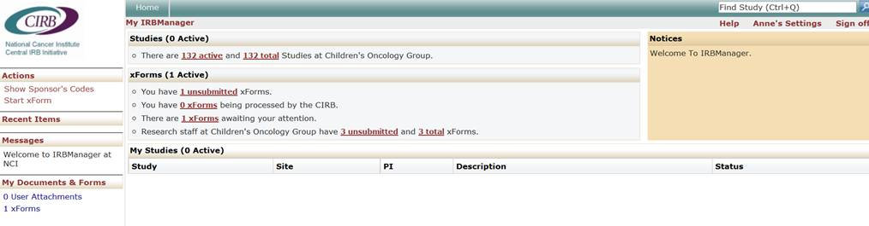
Figure 1
Step 3

Locate your most currently approved Worksheet. See arrows in Figure 2.

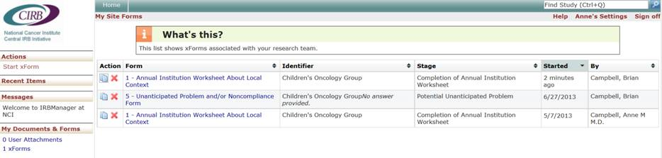
Figure 2

How to Copy and Edit

Step 4

Notice the icon in the left column titled “Action” in Figure 2. Click on this icon to create
a copy of your Worksheet. This icon has been circled in Figure 3.

Figure 3

Step 5

The following pop-up message will appear when the “Action” icon is clicked. See Figure
4. Click “OK” to continue.

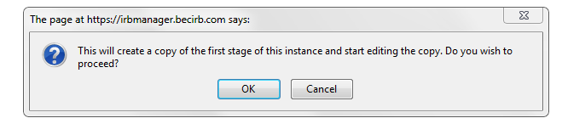
Figure 4

Step 6

A new window will open with the copied Worksheet. See Figure 5. Edit as necessary.
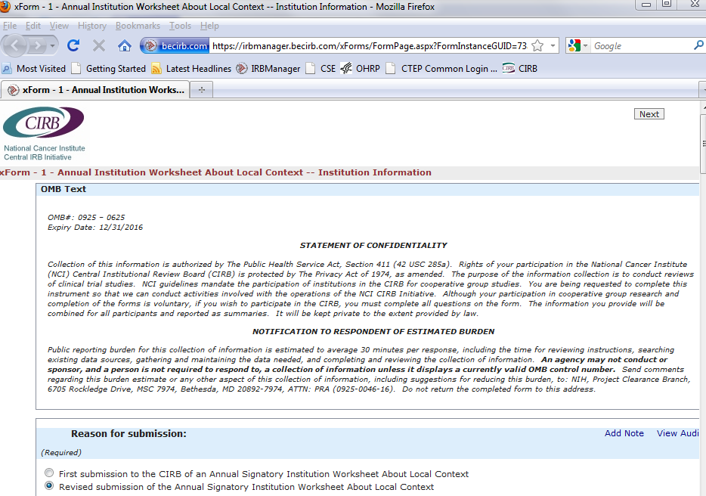
Figure 5

Step 7

Once all revisions have been completed, click “Submit” at the bottom of the last page.

Step 8

To see that your Worksheet has been submitted successfully, return to the Home screen, the xForm section, to see that you have an additional xForm “being processed by the CIRB.”

Appendix 2: List of Referenced URLs

CIRB Website Homepage
https://ncicirb.org

CTSU Website Homepage
https://www.ctsu.org

Checklist for Incorporating the CIRB into your Institution
https://ncicirb.org/Enrollment_Checklist.doc

CIRB Institution Enrollment Form
https://ncicirb.org/NCI_CIRB_Enrollment_Form.doc

CIRB Authorization Agreement/ Division of Responsibilities
https://ncicirb.org/AA_DofR.doc

Instruction Manual for Worksheet Completion in IRBManager
https://ncicirb.org/CIRB Instr. Manual for Worksheet Comp in IRBManager.doc.

CIRB Standard Operating Procedures
https://ncicirb.org/CIRB_SOPs.pdf

IRBManager Website
https://nci.my.irbmanager.com

Appendix 3: CIRB Operations Office Contact Information

Contact Information

Helpdesk Email: ncicirbcontact@emmes.com
Toll Free Number: 1-888-657-3711 from 8:00 am to 4:00 pm ET

CIRB Operations Office
c/o The EMMES Corporation
401 N. Washington St., Suite 700
Rockville, Maryland, 20850

Appendix 4: Key Terms

- Affiliate Institutions are defined by the CIRB as meeting all of the following criteria:
• The local context considerations of the Affiliate Institution are the same as the Signatory Institution;
• The boilerplate language and institutional requirements of the Affiliate Institution are the same as the Signatory Institution; and
• The conduct of research at the Affiliate Institution is monitored by the same office as the Signatory Institution.

- Boilerplate language is the information added by the Signatory Institution Principal Investigator to the CIRB-approved consent form after the CIRB approves it. Boilerplate language provides information that is institution-specific and addresses local context considerations for the Signatory Institution and its Component and Affiliate Institutions. This information may include contact information for the Signatory Institution Principal Investigator, institution-specific injury language, institution-specific pregnancy language, and other institution-specific information. Updates to boilerplate language must also receive CIRB approval prior to implementation.

- CIRB refers to all four CIRBs unless otherwise stated.

- Component Institutions are defined by the CIRB as meeting all the following criteria:
• The Component Institution operates under a different name than the Signatory Institution, but the Signatory Institution has legal authority for the Component Institution;
• The FWA number for the Component Institution are the same as the Signatory Institution;
• The boilerplate language and institutional requirements of the Component Institution are the same as the Signatory Institution; and
• The conduct of research at the Component Institution is monitored by the same office as the Signatory Institution.

- Continuing Noncompliance is a pattern that, if unaddressed, could jeopardize the rights and welfare of research participants or the integrity of the study data due to noncompliance with the protocol, Federal regulations, and/or the requirements of the CIRB.

- Serious Noncompliance is noncompliance that adversely affects the rights and welfare of study participants or results in any untoward medical occurrence that meets the criteria of “serious” or significantly impacts the integrity of study data.

- Signatory Institution is the institution that signs the Authorization Agreement and Division of Responsibilities document and has a direct relationship with the CIRB. The responsibilities of the Signatory Institution are listed on the Authorization Agreement and Division of Responsibilities document. Signatory Institution Principal Investigators must be “employed by” or "have a relationship with" the Signatory Institution to be eligible to open studies.

- Signatory Institution Primary Contact is the person who acts as the point of contact for the CIRB should the CIRB have any questions about the research being conducted at the Signatory Institution, Component Institution(s), or Affiliate Institution(s). The Signatory Institution Primary Contact receives or is copied on all correspondence from the CIRB to the Signatory Institution and the Signatory Institution Principal Investigator(s). This individual is also responsible for the submission of Annual Signatory Institution Worksheet About Local Context, and may also assist with other Worksheet completion.

- Signatory Institution Principal Investigator is an investigator at the Signatory Institution who is a member of the group coordinating the study and therefore is able to open studies with the CIRB. The Signatory Institution Principal Investigator is responsible for the research at their institution and all research activities conducted by the research staff (including any research activity at Component or Affiliate Institutions) for all studies opened in their name.

- Unanticipated Problem is defined as follows:

1. The incident, experience, or outcome is unexpected (in terms of nature, severity, or frequency) given the research procedures that are described in the protocol or the investigator’s brochure and the characteristics of the subject population being studied while the protocol was followed as written;

2. There is a reasonable possibility that the incident, experience, or outcome may have been caused by the procedures involved in the research; and

3. Subjects or others are at a greater risk of harm (including physical, psychological, economic, or social harm) than was previously known or recognized due to the incident, experience, or outcome.

