New Online Application – UC Reliance Registry (UCI Relying Site)
*Create new application online by logging in using your UCInetID. Note: Fill out all sections of the application – below are key sections specifically related to the Reliance registration process.
- Section 1. Enter Title of Study as listed in the Registry.

- Section 2. Enter Level of Review as determined by Reviewing IRB

- Section 6. IRB of Record – Select the following:
  - Sub-section A. Yes, UCI will Rely on Another non-UCI IRB
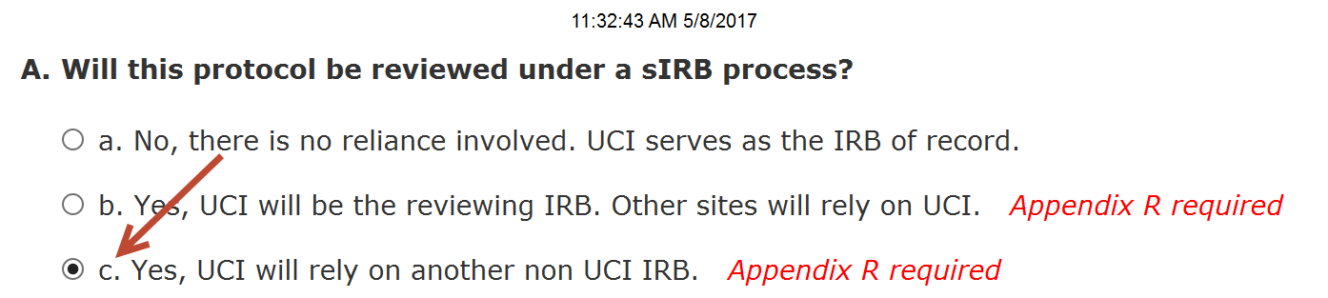
  - Sub-section B. Identify the sIRB collaboration – Select “University of California (UC) IRB Reliance”
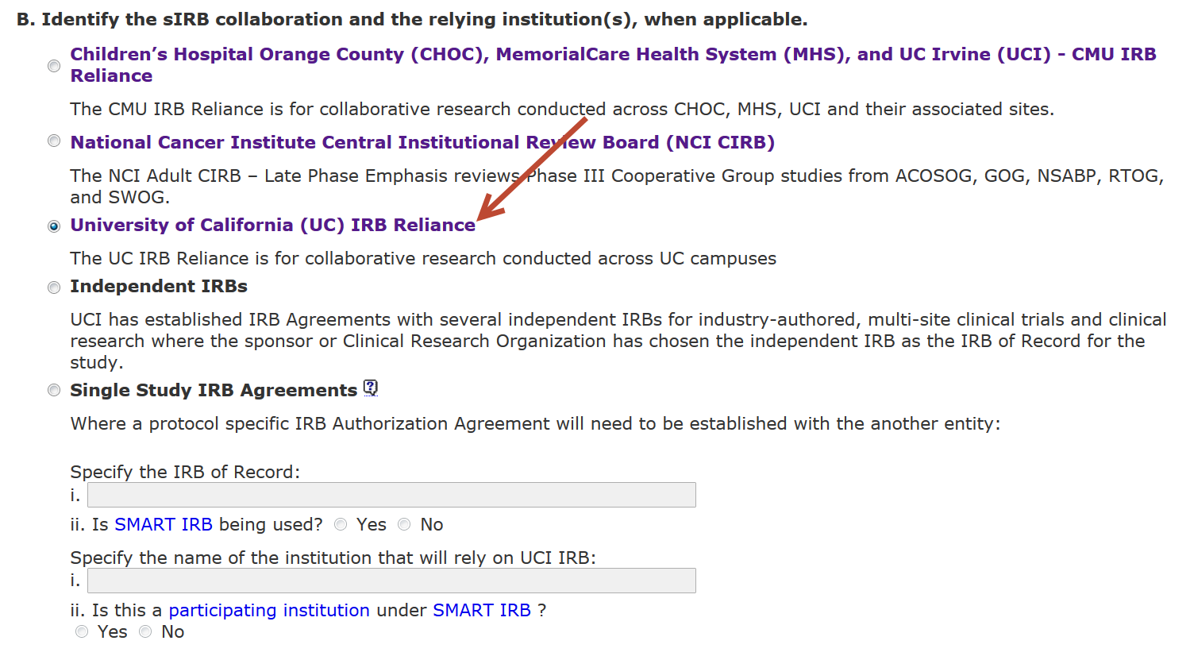
- Section 16. Upload Files –
  - Upload a copy of all Reviewing IRB’s study documents, if applicable:
    - IRB Approval Letter, with active approval dates
    - Protocol Narrative
    - Consent form
    - Recruitment materials
    - Questionnaires/surveys/measures, etc
    - Data Abstraction Sheet (for Records Review)
  - UCI Specific Documents
    - Upload Appendix R (sIRB / Reliance)
    - Upload Appendix T (Waiver of HIPAA Authorization), if accessing medical records
    - HIPAA Research Authorization Form, if applicable

