New Online Application – SMART IRB Agreement (UCI is the Relying Site - ORS)
*Create new application online by logging in using your UCInetID. Note: Fill out all sections of the application – below are key sections specifically related to the Reliance registration process.
- Section 1. Enter Title of Study as it appears on the IRB Approval Letter from the IRB of Record.

- Section 2. Enter Level of Review as determined by Reviewing IRB

- Section 6. IRB of Record – Select the following:

  - Sub-section A. Yes, UCI will Rely on Another non-UCI IRB
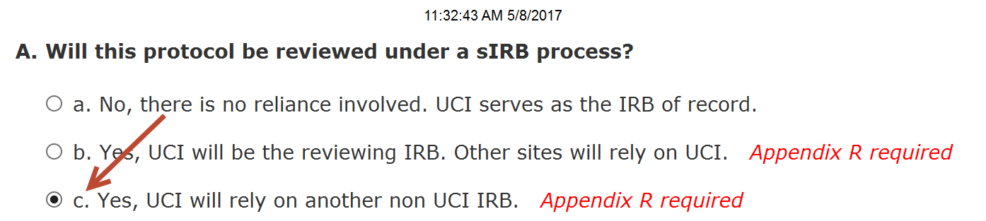
  - Sub-section B. Identify the sIRB collaboration – Select “Single Study IRB Agreements” and indicate the Reviewing IRB. Confirm SMART IRB is being used by selecting ‘Yes.’
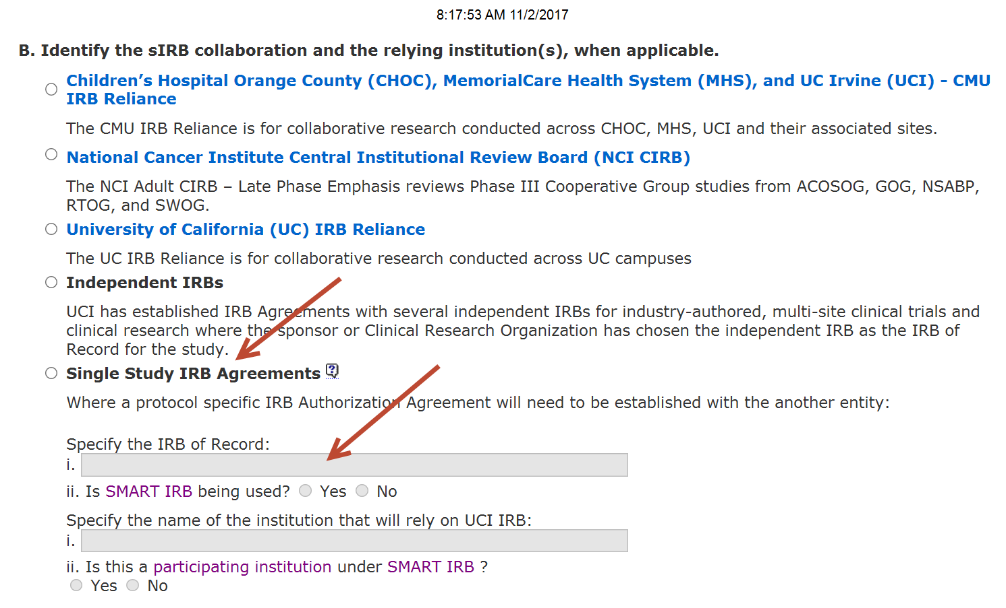

- Section 16. Upload Files –

  - Upload a copy of all Reviewing IRB’s study documents, if applicable:
    - IRB Approval Letter, with active approval dates
    - Protocol Narrative
    - Consent / Assent form(s)
    - Recruitment materials
    - Questionnaires/surveys/measures, etc
    - Data Abstraction Sheet

  - UCI Specific Documents
    - Upload Appendix R (sIRB / Reliance) – Note: Section B. Study Team Members (Please list only UCI affiliated study team members)
    - Upload Appendix T (Waiver of HIPAA Authorization), if accessing medical records
    - HIPAA Research Authorization Form, as applicable

